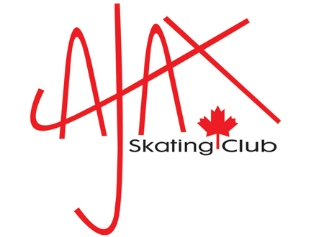

2022-2023 AGM & Awards Presentation

Attention: All 2022-2023 Members of the Ajax Skating Club

The Ajax Skating Club will be holding our Annual General Meeting and Awards Presentation on Tuesday May 9th, 23 at 6:15 p.m. (It is expected to be over by 7:00 p.m. for those of you with skaters participating in CanSkate on this day)

The meeting will take place in the Admiral’s Room at the Ajax Community Centre, 75 Centennial Rd, Ajax.

The Annual General meeting is an opportunity for current members to share in the decision making of the Ajax Skating Club and drive the future of the club. This meeting is very important for the ongoing operations of the club. Please make time to attend this important meeting.

Voting will take place during the meeting for the Club’s Board of Directors. This is an excellent opportunity to give back to the Club. The Club relies heavily on the support of our volunteers and cannot continue without our members supporting the Board of Directors at this meeting. This year we will be electing for the following positions:

President (2 Year term)
Vice-President (1 year term)
Directors (2) (1 year term)

If you wish to nominate yourself or someone else, please complete a nomination form and submit it to the Ajax Skating Club office by May 2, 2023. Nominations from the floor at the Annual General Meeting will not be accepted.

Our Annual Awards Presentation will also take place during this meeting. Awards include CanSkate awards, STARSkate Awards, Program Assistant Awards, Coaching Awards and the VERONICA MACINTOSH MEMORIAL AWARD.

Thank you,
Ajax Skating Club Board of Directors

