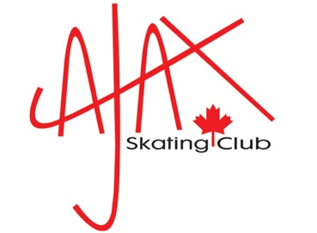
TYE DIE ORDER FORM

Please fill in for each item you are purchasing:

Skaters Name:

Type of Shirt (hoodie or crew):

Size of Shirt (see size chart on info sheet):

Colour:

Cost:

PAYMENT INFORMATION:

Please send an E-transfer to office@ajaxskatingclub.ca
In the note section, please include the Skaters name that is
registered with the club, tie dye, size and colour
i.e., Suzy Smith, tie dye, youth L, Pink
Remember to place your order by November 12th :)

